Q SCI 291
Application Problem Answers from our Text for Weeks 5 and 6

Problem 68, page 177
A) Step 1: f(t+h) = 29(t+h)² - 258(t+h) + 4658 = [29t² + 58th + 29h² – 258t – 258h + 4658]
Step 2: f(t+h)-f(t) = [29t² + 58th + 29h² – 258t – 258h + 4658] – 29t² + 258t – 4658 = 58th + 29h² – 258h
Step 3: [f(t+h)-f(t)]/h = 58t + 29h – 258
Step 4: as h →0 we have 58t -258
B) t=12, so p(12) = 29(12²) – 258(12) + 4658 = 5738 and p’(12) = 58(12) – 258 = 438
In 2017, 5738 thousand metric tons of copper are consumed and this quantity is increasing at a rate of 438 thousand metric tons per year.

Problem 82, page 186
A) s’(t) = 0.06t³ + 1.2t² + 6.8t + 10
B) s(4) = 0.015 (4⁴) + 0.4 (4³) + 3.4 (4²) + 10 (4) + 10 = 120.84
s’(4) = 0.06 (4³) + 1.2 (4²) + 6.8 (4) + 10 = 60.24
After 4 months, sales are $120.84 millionand are increasing at the rate of $60.24 million per month.

Problem 99, page 187
Find y’ = 25x^{-1/2}
A) for x = 1, y’ = 25 items/ht
B) for x = 9, y’ = 8.33 items/ht

Problem 40, page 193
Approximate change in revenue: dR = R’(x)dx = (200 – x/15)dx With dx = 10 and x = 1500, we find dR = 1000
Profit: P(x) = R – C = [200x – x²/30] – 72000 – 60x = 140x - x²/30 – 72000
Approximate change in profit: dP = P’(x)dx = (140 – x/15)dx With dx = 10 and x = 1500, we find dP = 400
If dx = 10 and x = 4500, we find dR = (200 – 4500/15)10 = -1000 and dP = (140 – 4500/15)10 = -1600

Problem 42, page 193
V = (4/3)Πr³ and dV = V’(r)dr = 4Πr²dr With dr =0.3 and r =5, we find dV = 94.2 mm³

Problem 28, page 201
A) average cost = c(x)/x = [20000 + 10x]/x; when x = 1000, c(x)/x = [20000 + 10(1000)]/1000 = $30
B) marginal average cost = c’(x)/x = -20000/x²; when x = 1000, c’(x)/x = -20000/1000² = -0.02
At a production level of 1000 dictionaries, the average cost is decreasing at a rate of .02 per dictionary.
C) average cost per dictionary when 1001 dictionaries are produced is: $30 - .02 = $29.98/dictionary

Problem 38, page 202
A) solve price-demand equation for p: p = 300 – x/30 domain is: 0 < x < 9000
B) c’(x) = 30
C) R(x) = xp = x(300 – x/30) = 300x –x²/30 domain is: 0 < x < 9000
D) R’(x) = 300 – x/15
E) R’(3000) = 100 and indicates that at a production level of 3000 sets, revenue is increasing $100/set. R’(6000) = -100 and indicates that at a production level of 6000 sets, revenue is decreasing $100/set.
G) profit (P(x)) = R – C = 270x – x²/30 – 150000
H) P’(x) = 270 – x/15
I) P’(1500) = 170 and indicates that at a production level of 1500 sets, profit is increasing $170/set. P’(4500) = -30 and indicates that at a production level of 4500 sets, profit is decreasing $30/set.

Problem 44, page 203
A) R(x) = xp = x(60 – 2 sqrt(x)) = 60x – 2x^{1.5}

B)
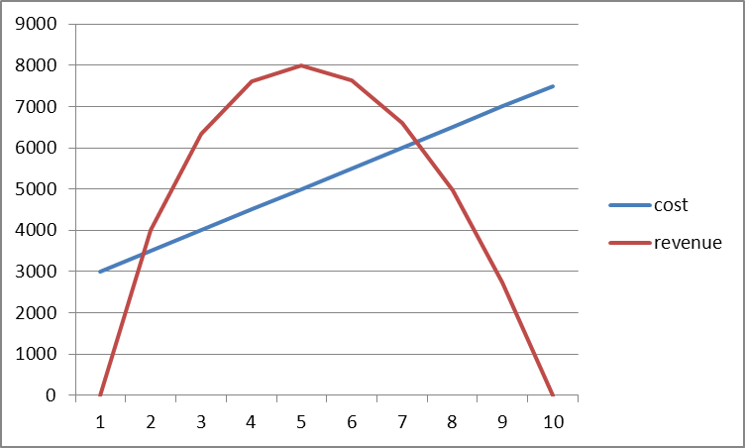

Two break-even points where the lines intersect. This is at approximately x =81 and x = 631. At either point profit = 0. Maximum profit is when x = 345 (approximately).

Problem 18, page 215
A) A = 10000e^{0.0364*3} = $11153.85
B) 11000 = 10000e^{0.0364t} or 1.1 = e^{0.0364t} and ln (1.1) = ln (e^{0.0364t}) thus 0.0953 = .0364t and t =2.62 years
Problem 22, page 216
A = Pe^{rt} so we have: 195000 = 99000e^{15r} Use same procedure as in previous problem to find r .0452

Problem 36, page 216
One way to solve is to find r = -ln 2/t = -0.6931/90 = -0.0077. A second way to solve is to recognize that the half-life is the time (t) when half of the original substance is gone. Thus, we can state this as: Q = Q₀e^{rt} where Q is amount of substance at t and Q₀ is amount at t = 0. Since 50% is present at the time of half-life, we can write: 0.5 = e^{90r} and solve for r = ln (0.5)/90 = -0.0077.

Problem 54, page 225
A(t) = 1000*2^{4t} = 1000*16^{t}
A’(t) = 1000*16^{t}*ln 16
A’(1) = 1000*16*ln 16 = 44361.42 bacteria/hr (rate of growth at end of the hour)
A’(5) = 1000*16⁵*ln 16 = 2907269992 bacteria/hr (rate of growth at end of the fifth hour)

Problem 58, page 225
N’(t) = 6/t; so after 10 hrs of instruction and practice the rate of learning is 6/10 = 0.6 words/min per hr of instruction and practice. After 100 hrs of instruction and practice the rate of learning is 6/100 = 0.06 words/min per hr of instruction and practice.

Problem 84, page 232
A) N’(t) = 720/(t+4)²
B) N(16) = 180(16)/20 = 144; N’(16) = 720/400 = 1.8
After 16 months, there are 144000 subscribers and is increasing at the rate of 1800/month.
C) 144000 + 1800 = 145800

Problem 88, page 233
A) Product Rule: T’ = x²(-1/9) + 2x(1- x/9) = -x²/9 + 2x – 2x²/9 = 2x – x²/3
B) T’(1) = 2(1) – 1/3 = 5/3 F per mg of the drug; T’(3) = 2(3) – 3 = 3 F per mg of the drug; T’(6) = 2(6) – 12 = 0 F per mg of the drug.

